# DETAILED EXPLANATION OF PROPOSED ALGORITHM

**PRE ASSUMPTIONS:**

1. All vehicle owners are having the application installed in their smart phones.
2. All routes are having a status which is good for driving.
3. All vehicles are in well (Each part is working correctly) condition during driving.
4. All vehicles can easily follow and apply the instructions provided by the app.

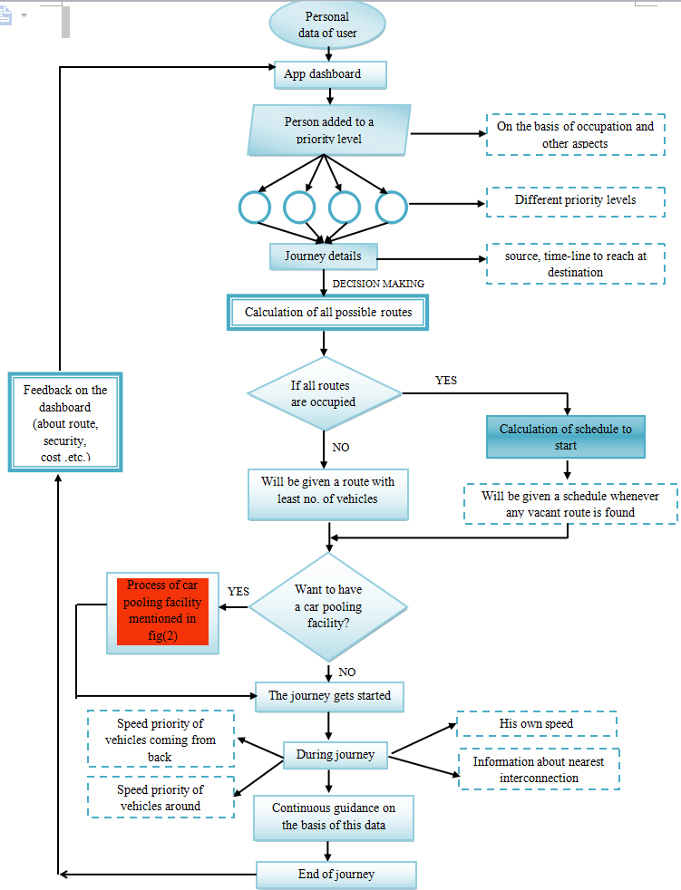

**Fig: Algorithm of the proposed solution.**

We are discussing here a possible **Algorithm** at a very basic level**,** how the proposed solution can be provided to people:

1. After installing the application, user will enter his personnel details into app dashboard and according to owner’s occupation (many other aspects can be considered their) his vehicle will be added to one of these following priority levels*:
2. Doctor (D)- Ambulance etc.
3. Officials (O)- Government Officers etc.
4. Public Transport (PT)- Roadways Buses etc.
5. Private Transport (Pr. T)- Personnel Cars etc.

**\*These are written according to maximum to minimum level of priority.**

1. After adding all his details, before starting his journey, he will enter his Destination* details and the timeline to reach the destination.

*Outside the defined boundary of Pune then by default the destination will be considered as the boundary of Pune.

1. According to timeline (**and other aspects like cost, security, route status etc**.) all possible routes will be calculated, connecting starting point and desired destination.

[4] Now, if ‘x’ no. of vehicles can commute on a subroute (A path connecting the

starting point and nearest junction) simultaneously without congesting it then the path

having **least no. vehicles** will be considered first.

[5] If all the calculated paths have ‘x’ vehicles then he will be given such time* at which

any of the subroutes get any vacancy.

*This can be calculated because speed of the vehicles on the roads and their respective distance from junction can be easily known using GPS technology.

***After allotment of Route, He can click on a special option of ‘carpooling’*.***

**\*Using carpooling facility, more contribution of the car owners can be obtained, they can pair their selves to any vehicle less passenger ( having same destination and subroute) and the vacancy of their vehicle can be completely utilized.**

**#Car owner will define his different terms and conditions for sharing his car through app and accordingly he will get a list of passengers who agree to him.**

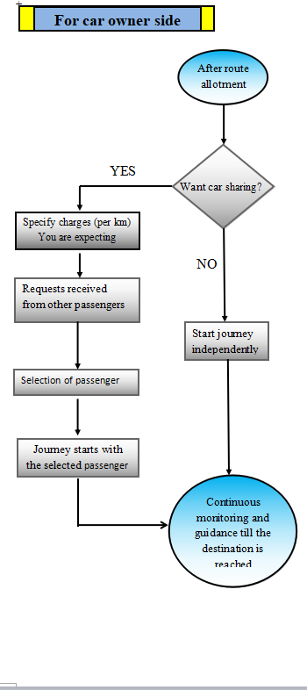

**Fig: Carpooling facility used by Driver of the Car**

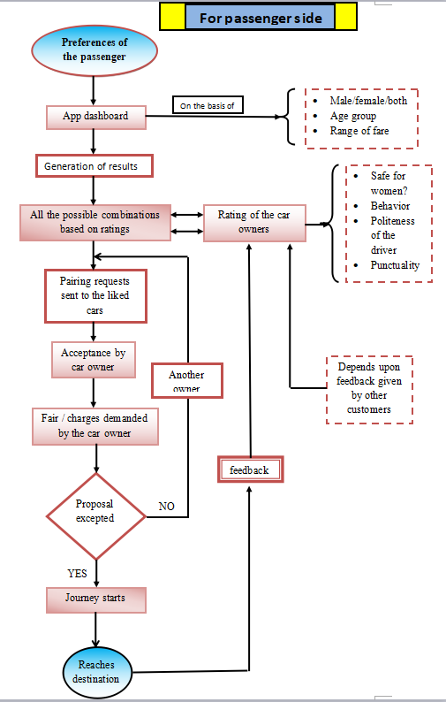

**Fig: Use of Car Pooling by a vehicle less person**

**I. If he says ‘YES’**

1. He gets a list of interested passengers, who agree with his different terms and conditions.
2. Selects the desired passenger and start his journey.
3. Receives the passenger on his way to destination and continue his journey with him.
4. Drops the passenger on his destination gets predecided fair and continue his journey.
5. **If he says ‘NO’ –** He will continue his journey independently.

* **To get the same facility passenger will do following operations:**

1. Passenger will give his preferences through app about drivers.
2. Accordingly, he will get a list of drivers which are on the same route to his destination.

**The Results Will Be Generated On The Basis Of Driver Ratings (On Basis Of Punctuality Etc.) given By Previous Passengers.**

1. Now he will sent a pair request to desired driver.
2. Information about his charges will be shown and if he agreed, he will paired to the driver and if he doesn’t he will find another desired driver from the generated results and will be paired with him.
3. After receiving the car he will start his journey with the desired car owner.
4. Reaching the destination, he can give his feedback which will be added to driver’s rating.

[6] During driving, with the help of Mobile application, each vehicle (Owners having

app) will send/receive two important data to the vehicles which are just ahead and

after it. These two data are: **The Person belongs to which priority level (D, O, PT,**

**Prt)** and **There speeds.**

On the basis of continuously tracking these information and the no. of vehicles on the same route, the person will be continuously guided by the installed mobile application (As the name suggest) about his speed such that, he will never face a Traffic Jam and will reach his destination before his timeline.**Ex-** Suppose, If a vehicle having more priority and speed ‘s1’ is ahead and a vehicle having less priority and speed ‘s2’ is after the user having speed s, then the user will be advised to have a speed-

**s1>s>s2.**

**\*Similarly, The proposed logic can be applied to each and every triplets of vehicles on the road.**